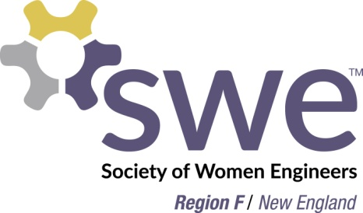

FY18 Region F Awards Nominations Overview
The FY18 Region F Awards will be presented at the WE Local Conference in Providence, RI on April 21, 2018. These awards are based on nominations, which will be submitted to the FY18 Region F Awards Committee using the online form by Sunday, March 3, 2018. Any SWE member in Region F may submit a nomination. Individuals may submit multiple nominations. This will be the final set of Region F Awards since SWE reorganization eliminates regions.
The nominations will be reviewed and winners will be selected by the FY18 Region F Awards and Executive Committee.

Professional/Collegiate Section Awards
One professional section and one collegiate section will be selected as a recipient for each category (with exception for ERG Award).
Employee Resource Group (ERG) Award (professional section or MAL only)
In recognition of Professional section or MALs working with one or more Employee Resource Groups that mutually benefit both parties. The award nomination packages also collect best practices that can be featured in SWE media.
Selection Criteria
- 45% SWE Participation: Include details about how SWE has helped the ERG and how SWE benefited from the partnership.
- 45% ERG Participation: Include details about how the ERG’s participation helps SWE, what percentage of the ERG are SWE members. Describe how the ERG benefited from the partnership.
- 10% Best Practice Sharing: Include details that will allow other MALs, Sections, and ERGs that can be used to help partner these organizations to develop similar partnerships. “What we’d do better/different next time” type statements are important.
Outreach Programs Award
In recognition of a significant contribution in the area of outreach. Significance can be in the form of innovative program and/or delivery, or in terms of audience numbers reached.
Professional Development Programs Award
In recognition of a significant contribution in the area of professional development.
Membership Programs Award
In recognition of a significant contribution in the area of membership. Significance can be in the form of an innovative membership event or program, or in terms of the impact on membership retention or growth.
Outstanding Communications Award
In recognition of a significant contribution in the area of communications. This section exhibits strong internal and external communications, which may include the section website, use of social media, section newsletters, and contributions to the Region F blog.

Individual Awards
One recipient will be selected for each category.
Distinguished Service Award
In recognition of a member who has made significant contributions to her section, our region, and the Society in multiple areas over an extended period of time. The recipient must have at least 10 years of experience.
Significant Support Award
In recognition of a member or company who has made an outstanding contribution to financial support of region activities.
Collegiate Emerging Leader Award
This award honors a SWE collegiate member who has made significant recent contributions to her section and/or our region and the Society. The recipient must be no more than 1 year out of college as of the end of FY18.
Professional Emerging Leader Award:
This award honors a SWE professional member who has made significant recent contributions to her section and/or our region and the Society. The recipient must have no more than 10 years of experience.

FY18 Region F Awards Nominations Submissions

Any Region F member may submit a nomination or nominations for the FY18 Region F Awards by submitting the required information below using the online form by March 3, 2018. If you have any questions, please contact Region F Governor, Anne Russo, at governor-f@swe.org. To submit multiple nominations, please submit multiple forms.

1. For all submissions
Name of nominator:
Nominator section:
Nominator member number:

2a. For collegiate/professional section awards
Section name:
Section number:
Award nominating for:

2b. For individual awards
Nominee name:
Nominee section:
Award nominating for:

3. Please explain why the nominee is deserving of the award selected.
Recommended length: 500-750 words.

Link to online form

