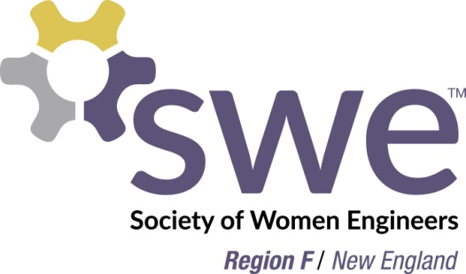
Region F Mentoring/ Pipeline Interest Form
The goal of the mentoring and pipeline program is to identify eligible candidates for SWE positions and help members meet their future aspirations.
Contact
Name:
Email:
Phone:
Education/ Work Background
Major:
Highest Degree:
[ ] Bachelors [ ] Masters [ ] PhD
Current Employer/ Position:
SWE Experience
Membership #:
Join Date:
Past Positions:
SWE Public Speaking Engagements:
Desired Next Position:
Future Aspirations:
Mentoring
Interested in finding a SWE mentor?
Interested in mentoring another member?
Mentoring Goals (check all that apply):
[ ] Learning how to move forward in SWE and opportunities of different positions
[ ] Learning more about SWE bylaws and policy
[ ] Career mentoring
[ ] General networking

Return Form to Region Nominating Committee Chair:
Jennifer Lynch (jennydl@comcast.net)

Note: Information provided is seen only by the Region Governor and Region Nominating Committee Chair
You do NOT need to be interested in the mentoring program to become part of the Region F pipeline

