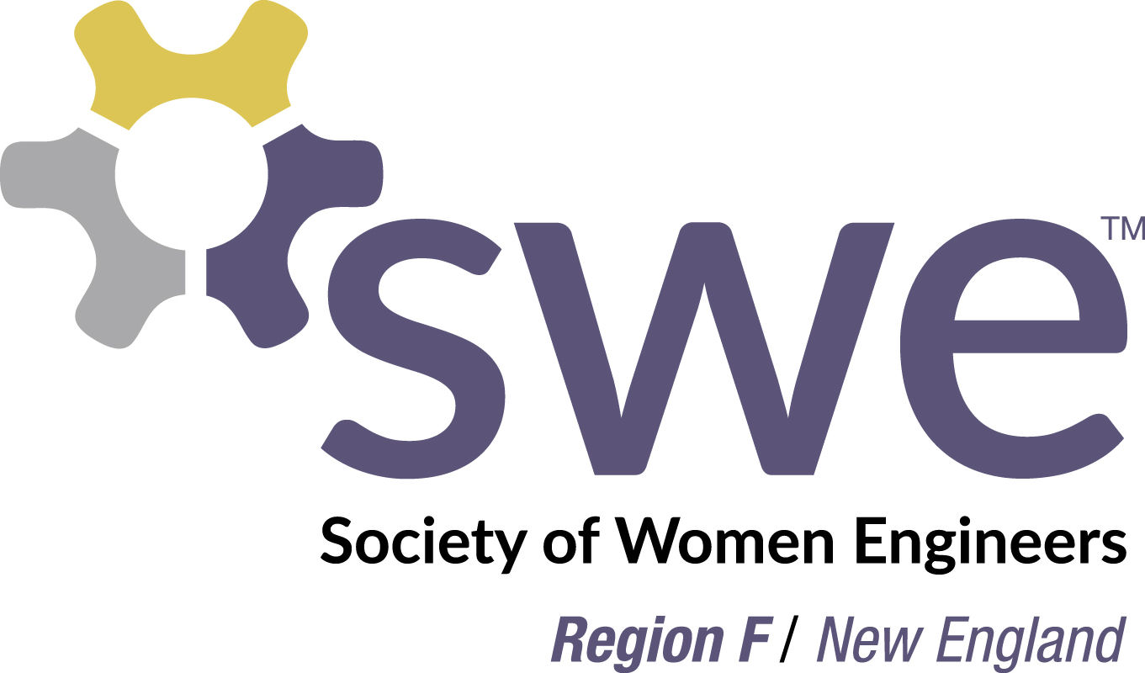

Region F Expense Reimbursement Form

This form is to be used to request reimbursement for authorized SWE Region F Section expenditures. Reimbursement is contingent upon adequate funds remaining in the specified budget line. Please complete the information requested and return it with electronic copy of receipts (PDF or photo only or forward receipts received by email) within 60 days after the event and no later than June 15th of this SWE Fiscal Year to the SWE Region F Treasurer at:
regionf.treasurer@swe.org
FY16 SWE Region F Treasurer is Elizabeth Peterson

Date of Request:
Name:
SWE Section Name:
Make Check Payable to:
Mail to Attention of:
Address:

All receipts must be legible and include the transaction date. Only travel expenses reimbursed are lodging, transportation (including baggage fees), and early bird conference registration fees up to the amount approved by the Conference Support committee or Region Governor.

Description of Expense: | Date: | Amount: | Budget Line Item  (for Treasurer use):
TOTAL TO BE REIMBURSED:

Please check here if you would like your reimbursement check to be used as a donation to the Society of Women Engineers Region F. Receipts must be submitted even if donating expenses. You will receive a letter thanking you for your donation and to use for tax purposes.

For treasurer use:
Pre-approved by officer contact: Date

Budget review by treasurer: Date

Account #: ____________________ Check #: _____________ Date

